KARIBU, KENYA
Erin Sinclair
December 2010
PLNT 4790
Dr. David Wayne Wilson

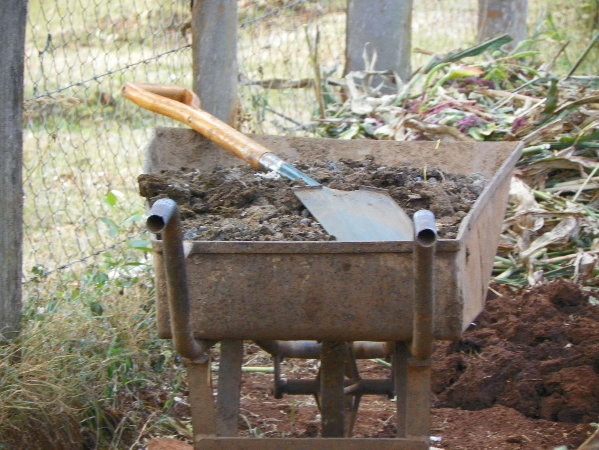

INTRODUCTION
On December 11, 2010 I set off to the “Dark Continent”. This nick - name has never sat well with me and after nearly twelve days on the Dark Continent, I now understand why. As a modern society the very word “dark’ can mean or not mean many things. I, by my own standards, find the word to be just as it spells, dark. Not to my surprise I found this misunderstood continent to be far from dark. In fact, I found it to be not only full of light but, enlightening. People in the western hemisphere of the world find things enlightening that are of a material nature. I have found that to be the very opposite in Africa. When viewing the world from a non- ethnocentric point of view, erasing all preconceived notions, and stepping out of the box, I have found that the most beautiful things begin to blossom.
Kenya… Oh how you were so very hard to get to but, you were so very worth it. “Nothing that comes easy is worth having” has been repeated to us throughout our lives. I must say that this old adage holds true when describing my journey to Kenya. After nearly three days of travel, I can attest that Kenya was worth the wait. The people, the landscape, the way of life, and the indescribable energy are intangible objects that have branded my soul and will forever hold a special place in my heart. Kenya and the individuals that I traversed countless miles with in a hot bus have refocused and validated my new direction in life.
I hope that this paper will bring you joy and understanding. It is my wish that you will smell the fires burning, hear the birds chirping and feel the children laughing. I have compiled a series of topics that I found interesting while I was in country. The information that I did not fully understand, I have researched and included. To enhance my understanding, I have interviewed the University of Wyoming’s new student and friend, Judith Odhiambo, which I met in Kitale, Kenya. It is my wish that you enjoy this paper as much as I have enjoyed reminiscing while writing it.
Hakuna Matata,
Erin

British Colonization
I will begin with a little Kenyan history that I obtained the last day of my visit in Kenya at the Nairobi Museum. This trip to the museum brought many things that I had seen and witnessed, while traveling, into a clearer perspective. I discovered that Kenya (particularly the Great Rift Valley of Kenya) is home to some of the earliest evidence of human existence.
In the late 1800’s the British began economic development in Kenya. This began the discourse among tribes. The British however, did bring a railway to Kenya. This railway helped to establish the city that we now know as Nairobi. I am not sure if this establishment helped the country or hindered it. I do feel that without an “industrialized” center, Kenya may have been susceptible to a rule far worse than that of the British.
Although the British brought many new and exciting ideas to Kenya, some Kenyans did not agree with the pressures. The Mau Mau warriors were the first to rebel against the British and even began killing Kenyans that they perceived as loyal to the British. After a series of violent events, Kenya gained its independence from England in 1963. Although Kenya is now considered an independent country, the British culture still has a dominating presence. I visited the Nairobi museum and was introduced to the ways in which British influence changed the tribal culture of Kenya during its rule. Like all western civilizations, the British created a set of norms that were acceptable and not acceptable. In the creation of these norms, they created hostilities among tribes that typically, prior to British rule, existed peacefully together.
Judith Odhiambo acknowledges that she is not a historian but from her understanding, the influence that British Colonization had on Kenya, as a whole, was a severe division among tribes which created “tribal hatred.” By way of the museum, I observed evidence that suggested deviation away from a simple way of life into one of materialistic ideologies.

The Perceptions of Americans
Kenyan perception of the western world is more than apparent in everything that a traveler does in Kenya. The simple purchase of a souvenir in the market can be an eye opening experience. According to Judith Odhiambo, the perception that Kenyans have of the “white man” is very simple. “The white man is superior and is respected.” and “America as a country is a small heaven.” In my opinion, there are several reasons for this perception. First, throughout history the “white man”, whether he be American or other wise, has always descended upon Africa as a savior or a dictator. The Africans, in my observation, are generally very passive people. They are also very trusting. Therefore, to have the white man descend upon their lands and promise them better gardens as well as improved living standards could be rather entising to a trusting individual. Furthermore, the white man often comes with new technologies and access to many new and advanced ways of thinking. The unfortunate reality of this situation is that, historically, the white man’s intention has been to control and conquer a country in the attemot to prove its dominance to the rest of the developed world. This process has surpressed the indigenous African culture which has created war and greed. Westerners have destroyed the very necessities that have sustained Africa for years, leaving it in tormoil and unrest.
The beautiful thing is that Africa, in particular Kenya, is coming out of this sinking ship with a new sense of nationalism. The many NGOs that we visited in Kenya are helping their communities to make themselves sustainable. The American aid and research that has been done in Kenya over the past several years has not gone to waste and the Africans are beginning to see the Americans as partners instead of superiors. I believe that the Kenyan people will always be greatful to the help that they receive from Americans but I hope that in the end they will see that it was them, the Kenyan people, that brought the country back to sustainability. It is my hope that this new confidence will guide them into a feeling of equality.
Community Gardening
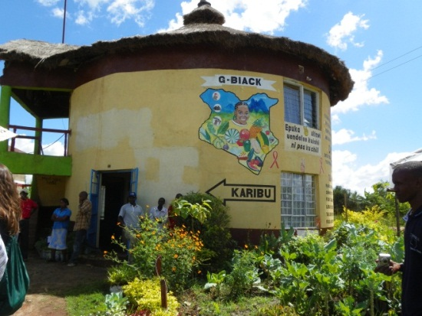
Community gardening is very common in the agricultural region of Kenya. Although, mono cropping is still the most prevalent type of agriculture, community gardening is sustaining the average family. There are several NGOs in the Kitale area that began with the education they obtained at Manor House. These groups have taken their acquired knowledge and spread it throughout the region. They range from small communal type gardens to institutions that provide free education and information to the local population. It is my understanding that these organizations either grow crops for their own consumption and then selling the excess or, they grow the crops and sell the harvested ones to fund the institutions. These institutions provide the much needed agricultural education to the Kenyan people. It is encouraging to witness so many small NGOs attempting to promote bio intensive agriculture in the western part of Kenya. Furthermore, it is a testimony to the work that is done at Manor House. The drive that the Kenyan people have to feed their communities has far surpassed that of the United States. In the United States we simply toss money at the problem through social welfare programs. In Kenya, the Kenyan people have developed a way to educate their population. This education will teach individuals how to care for their own population through sustainable means. This creates a sense of pride and ownership. It also creates a strong sense of community which, I would suspect, will reduce the crime rate and create a greater sense of nationalism.
The United States is doing an injustice to its people by providing them with the means to excel their economy of consumption. In the end, these individuals will not have obtained the knowledge of how to care for themselves. They will have only learned how to work the system so that they can have what they desire. The ideal ology that one needs to go to the super market to obtain their daily necessities has prevailed over the basic need for nourishment. If an individual knew and understood exactly where and how their food was produced, the waste would decrease and the mass consumption would stop.
In Kenya, people use the very last of their harvest. They eat the little left overs that they may have. Kenyans are creative with their food and share their harvests with their neighbors. This sharing may often be through that of trade. They do not allow their precious self – produced, community - grown crops to go to waste. It may take a little more effort to barter and trade but in the end the crop is a part of the individual and they will not allow their hard earned crops to go to waste.
The Soil Profile
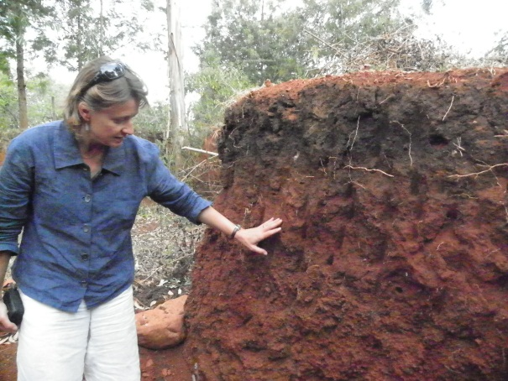
Being a new “nerd in training” I had been exposed to the idea of soil profiling but had never put it to use. Dr. Urszula Norton provided the group with a soil profiling experience. This experience explained the soil horizons in terms that answered questions and that were applicable to the environments that we were experiencing in Kenya as well as those that we have experienced in Wyoming. These invaluable lessons have served well in the understanding of soils in the current semester. The hand texturizing technique was used to identify the different soil textures in each horizon. These textures contained a good deal of sand particles yet they were smooth. The smooth feeling did not dominate the grittiness and it made a ribbon over 2cm long (not exceeding 5cm) which indicates that the predominate soil texture in this profile was a clay loam. We also made an observation that led us to believe that much of the settlement in the profile was due to erosion and some compaction that was created predominately by human disturbance. This experience solidified my decision to minor in soils. I believe that the simple understanding of soil leads to a more successful crop.
The soils of Kenya are very rich in a red color and are used as body paint in many of the tribal cultures; it is also used to color and mold hair in many ceremonies. The soil is a big part of the Kenyan culture and sustainability, regardless of tribal affiliation. Carrying this knowledge back to the States, I now understand what a large part of our everyday lives soil is. It is the very foundation for our roads, our food, our clothes, our home lawns and, even our cities. The soil profile adventure was not only an intimate experience with the Kenyan earth, it was an eye opening experience into the importance of soil in the world.

Double Digging
Before my arrival to Kenya, the idea of “Double Digging” was absolutely foreign to me. I gained an understanding of this concept while I was in Kenya. The real understanding of the mechanics came after speaking to Judith Odhiamdo. The application of double digging is very labor intensive to start with but, after, the initial “dig”, double digging serves the farmer well.
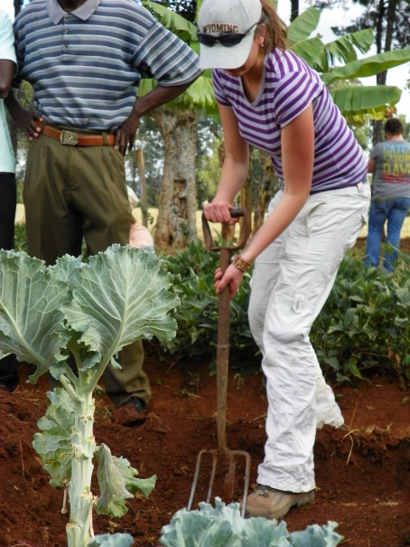
A bed should be prepared once every five years as follows: The bed, itself, should be approximately a meter wide and three meters in length. Its depth should be around two feet. The top six inches are to be above ground. The first section of soil is to be removed and set aside (this is only the first meter wide, a foot in length, and two feet deep.) The adjacent top foot is moved into the newly created hole as to “turn” the soil. This is repeated along the entire two foot depth of the bed until the end of this bed is reached and then the soil that was initially set aside is to be returned to the end. This finishes the soil rotation in the bed.
Double digging helps to preserve water in the soil and reduce weed infestation. The five year rotation serves to preserve the soils environment and its microbial population. Another important practice of double digging is to provide the beds with adequate humus material. This material helps to maintain soil temperature, decrease the evaporation of water, and increases microbial production. The above mentioned practices provide the optimal growing environment for plants. Hence, it increases plant health, production, and the amount of edible food for the farmers and their community.
The Great Rift Valley
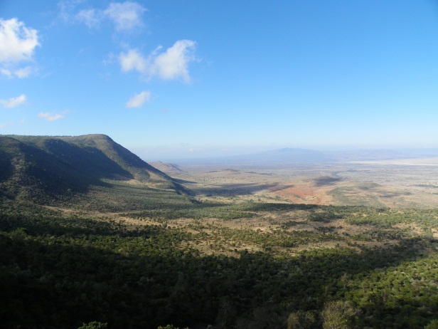
While traversing down a path that resembled a maintained road, we came upon a valley that took our breaths away. While shopping for a native gift for my daughter a local man asked me if I had ever been to the Rift Valley before. I, of course, replied no. In his broken English he began to tell me that African continent is splitting and the very valley I was viewing was where that was happening. Looking down through the valley I could see small fires burning. These fires were “charcoal ovens” that were converting the Iron Oxide clay into charcoal for cooking energy. The valley was bright and full of life. There was a slight haze from the water vapor that held onto the heat which encompassed the smell of fire and dust.
The Great Rift Valley extends from Lebanon to Mozambique and encompasses the western portion of Kenya. This great valley was created somewhere around ten to twenty million years ago. The creation forced volcanic activity from the earth’s core which, created the now famous Great Rift Valley. Many great archiological finds have been discovered here. These finds have been well preserved do to the alkaline nature of the soil created by the volcanic ash.(Ghose pp. 270 - 271 ) In the middle of its Kenyan valley is Kenya’s most fertile farmlands which we traveled through and studied. One of the main crops in the valley is tea and it is produced as a mono crop. A tea shrub can live for close to eighty years. Ideally, the top two leaves are harvested by handpicking. This handpicking creates a heathier plant but, some of the companies have employed a machine that cuts the plant evenly and takes off whatever material is in its way. These crops are mostly corperate and employ as well as house many Kenyans. The tea is distributed worldwide. Its two biggest exporters are England and Egypt. The Great Rift Valley is a geological masterpiece.
Maasai
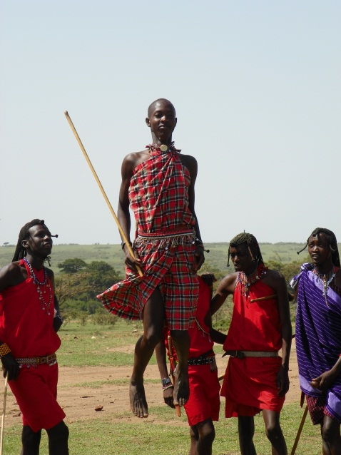
A traveler can see a Maasai herder in his red shuka, herding his cattle while conversing on the cell phone. To many this may seem very strange. After meeting, dancing, and listening to the Maasia tell their story, it is easily understood how this dichotomy could come to fruition. We all strive to belong to something. We all want to have a strong sense of belonging, yet we fail continually. The Maasai have retained their strong culture through many trying times. They have taught their children to respect this culture and instilled it in their pshyce. They are proud of where they come from and eager to travel to where they are going. The Maasai only allow what they percieve as beneficial into their culture and reject the outside pressures. Their indigenous culture is a choice and is well preserved through practice and respect.
The Maasai are a nomadic tribe whose life revolves around their self – proclaimed “God - given” cattle. Before the introduction and acceptance of maize, the Maasai cattle provided the Maasai people with their sole source of food. Even today, maize is only a small suppliment to the Maasai diet. The fermented blood and milk mixture creates the lean and muscular figure the Maasai people possess. The cattle also provide the Maasai with hides that allow them to create many useful products like that of mattresses, saddles and some protective clothing. The Maasai are considered feirce warriors. They have a complex caste system among the tribesmen. This system involves herding of cattle to that of a successful lion hunt which defines their manhood. The successful “lion killer” in the hunt becomes a chief and begins his own, independent community.
The Maasai are a polygymist society and the women are responsible for making the dwellings out of cattle manure and collected branches. They care for the children while the men are herding the cattle. The Maasai are humble and intent. They are firmly grounded in their ancient culture and remain proud, despite outside influences. The Maasai can eloquently be described by a quote from S.S. Sankan: “The Maasai have long remained the ideal mental conceptualization of the Western European idea of an African “noble savage.” Tall, elegant, handsome; walking with a gentle spring of the heel, seemingly proud and indifferent to all but the most necessary external influences.” (Barsby p. 19)
Women of Kenya
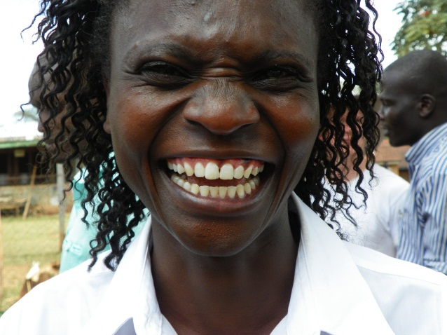
The women of Kenya project a quiet and helpful disposition. After speaking to many it becomes apparent that they do not run in the face of hard work. They rise before sunset to prepare meals for the family. They begin by fetching the day’s water and then return to serve their family breakfast. They then go and tend to the fields, cleanse their belongings and family, care fore the livestock and then prepare lunch. After lunch is consumed they return to the fields and perhaps often retrieve more water. I suppose while they are carrying their water upon their heads they are running through the rest of the day’s to – do – list. This list includes tasks like repairing torn clothing, harvesting the crops for dinner, gathering firewood, tending to their children and preparing for the next day. When asked, the female members of The Macedonian Women’s Group what the men do, the women playfully replied, “They go to the market and count cars.” Judith Odhiambo has informed me that the men do the manual labor of the day. These tasks may include plowing and heavy lifting.
The women seem very shy and reserved. They are taskfully oriented and do not respond well to simple jokes or playful gestures. Conversly, when relaxed they are warm and inviting, ready to share and more than helpful. They take their everyday tasks very seriously yet, they still find room to enjoy the simple things that life has to offer. You can see them doing their houshold laundry with their children. While hanging the clothes to dry they are playfully sweeping the wet linens across the faces of their kin, making them laugh as if they were in a game of peek-a-boo. Kenyan women find the joy in the simplicity of their everyday tasks, they embrace their lives and flourish from them.
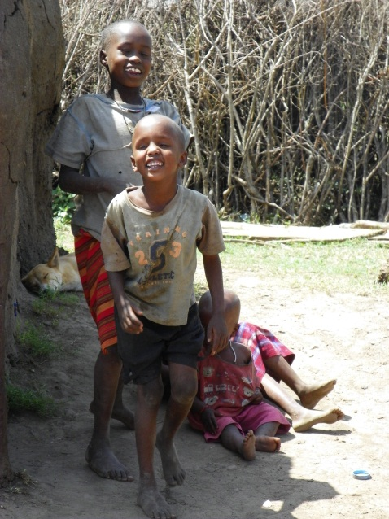
The Youth
Bare feet, torn clothes, curiosity, and beautiful smiles are the few amazing images that come to mind when thinking of Kenyan children. The lack of material goods enables these growing kids to enjoy each moment. Throughout Kitale a passer by can see soccer balls created from newspaper and twine. These balls are perfectly round in structure and are used to their capacity. Soda bottle tops are used to construct the wheels of their toy cars. These cars are constructed of wood scraps, old wire and the soda caps. The children are elated to see themeselves in a photograph and enjoy simply catching insects, throwing sand, or watching their elders work in the gardens. The youth in Kenya are very aware of what it takes to make their daily food. They participate in the daily activities of the farm and on demand can regergitate the proceeses. Kenyan youth are provided the opportunity to go to elementary school. The children are very excited about this opportunity. Their classroom size can exceed ninety children but, the class is very well behaved for the children realize what an amazing opportunity it is to have an education. To obtain an education beyond that of primary, the family must fund it or the child must obtain private funding from donors. This is rather difficult to do. None the less , the children are thankful for the education they receive.
The youth of Kenya are very happy with what they have. They enjoy the simple things in life and use their natural creativity to design the things they wish to have. Their smiles are intoxicating and their ability to enjoy nature is admirable. These children are the opitomy of peace, love, and joy.
The Epidemic
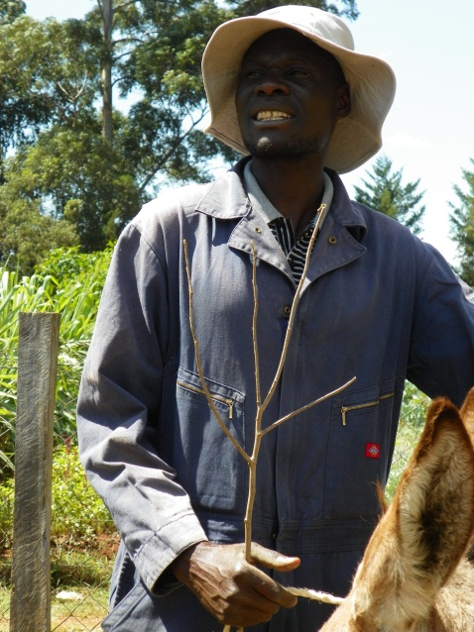
While in Kenya, it was explained to me that the infection of HIV was perpetuated by the raping of women and children. Our exposure to the AIDS epidemic was limited to children orphaned by parents who were plagued by AIDS. The people of Kenya care for the orphaned children as if they were their own. Some families, like Joshua of Manor House, take in several children and raise them as their own. It is estimated that seven percent of people living in Kenya are infected with the virus. According to a guide from one of the NGOs we visited, there is a growing movement to educate women on issues like birth control and safe sex. This education has had a positive effect on the birth rate. Before the increase in education occurred, each family had anywhere from eight to twelve children. Now the average number of children born to a Kenyan couple is around six. The rate of individuals affected with AIDS is slowly decreasing as well. These NGOs are incorporating safe- sex education into their agricultural education. They are focusing on the female population. This becomes particularly interesting because it was my observation that the females in Kenyan culture are the ones that hold the family and community unit intact. I believe that the incorporation of safe sex education with agricultural education serves a dual purpose. The Kenyan woman have gained trust in the NGOs for they are teaching them how to successfully feed their families. Due to this acquired level of trust, these women can also trust that the sex education they are receiving is valid and in their best interest. By decreasing the number of family members through birth control, they can better care of the members they have which, will increase existing member’s chance of survival through proper nutrition without competition. Compounded by AIDS prevention, the life expectancy of these members is increased as well. Therefore, the relationship between agriculture, family planning, and sex education proves to be a beneficial one.
Livestock
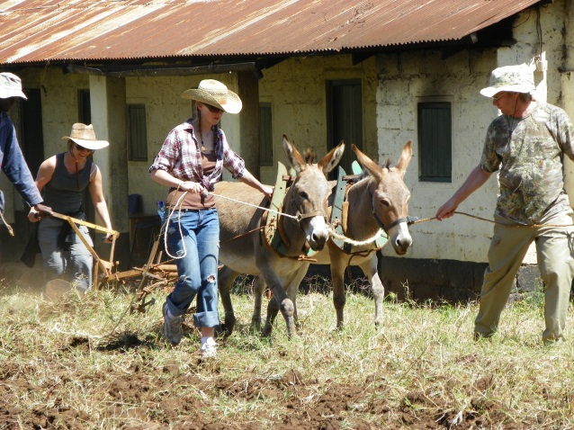
While traversing through Kenya the sounds of goats brand your eardrums. This innocent BLAHHH… becomes comforting over time. From my observation, goats are a main staple for milk and meat. Throughout the streets of even large towns, like Nairobi, a herd of goats can be seen grazing along the side of a busy street. Donkeys are the “workforce.” These animals provide the lucky Kenyans with a source of power. The donkeys drag carts and plows. They too can be seen grazing along busy streets. These animals are very agreeable for the most part although, you can randomly hear their disapproval through their infamous EEEH – AAAH. Chickens are incorporated into the Kenyan diet but, from my observation, they are mainly used for their egg production. As I learned from a chicken head served to me during my last meal in Kenya, chicken heads and feet are considered a delicacy. Even though it is insulting to Kenyans to refuse their offerings, I did not eat the chicken head for I feared that my gagging while attempting to eat it would have been far more insulting. Rabbits are a source of food. They reproduce quickly which provides a constant source of protein. There are programs in Kenya where a pregnant rabbit is given to a family. When the rabbit gives birth, the family returns one rabbit from the littler to the donor and the cycle continues. Many Kenyans are very inventive and create programs such as the one above to help their fellow community members. A notable problem with livestock in Kenya is the threat of theft. People go to great lengths to ensure the safety of their animals. From my observation horses are only for the wealthy and are kept under very close supervision. Due to the desert environment in the northern portion of Kenya, camels are used for work and transportation in this region. However, in Kitale they are mainly for visitor entertainment and very exciting to ride.

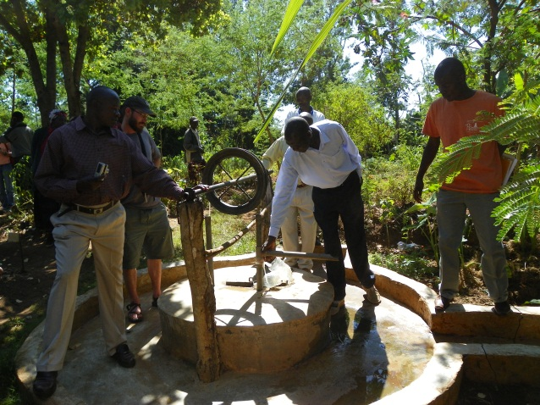
Water
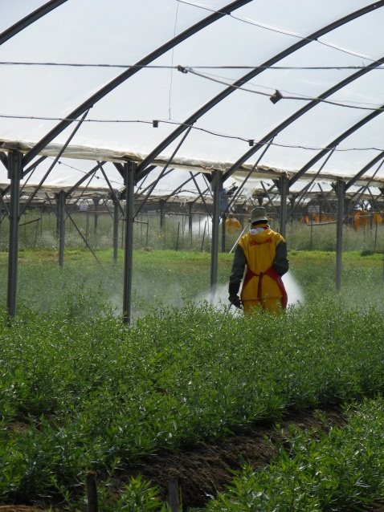
The water in Kenya is not treated like the water in the United States. As a traveler you must be very cautious not to drink any unfiltered or untreated water. One-third of the urban population in Kenya has limited access to water. This results in poor sanitation which leads to illnesses. The water that is accessible in rural areas, according to Judith Odhiambo, comes from streams or underground wells. However, this water is often plagued with diseases like that of collerea, dysentery, and typhoid. As a traveler it is advised to only drink bottled water. While observing this advisory, I felt very guilty. It was difficult to know and witness these facts while “chugging” my crystal clear bottle of water.
The streams are murky in color and are contaminated with fertilizers and pesticides used in agriculture. The mono crop systems that are rarely owned by Kenyans greatly contribute to this problem. The Kenyans are usually only workers on these properties. These systems also create an environment that promotes erosion and easily finds its way into the depleting water shed.
While traveling through Kenya you can observe men washing their motorcycles in a stream. Ten feet downstream children are playing in the water, splashing and laughing. Further down the stream women are collecting their water for the day. The local farmers generally only rely solely on the water that is provided to them through rainfall. The average monthly rainfall in western Kenya is eighty – eight mm. It receives rainfall nearly all year and accounts for most of Kenya’s agriculture. (Ghose p. 41)
Hells Gate
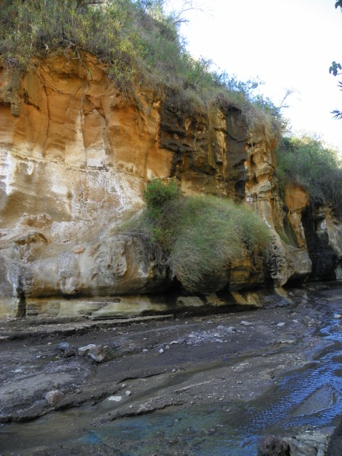
“Beware of the Baboons” is the welcoming sign at Hell’s Gate. The native baboons are the welcoming committee as well. As they run around chasing one another, they make the visitors laugh and remind them of the presence of nature. Hell’s Gate is a geological phenomenon. It is located in the southern part of the Rift Valley. The park is protected and is a Kenyan National Park. It is littered with volcanic ash and volcanic plugs. Black obsidian rock created by volcanoes is abundant. This rock is used by the indigenous people of the valley for making tools. The gorge that was created by a river can be traversed on foot. There are many treasures to be discovered at the bottom. These treasures include large insects and snakes. The terrain is challenging and very rewarding. A traveler must be adventurous and limber. The soil horizons are very distinct and diverse. The entire gorge is one large soil experience. The red clay is due to the oxidation of the soil that has left Iron Oxide deposits behind and is often used by the natives as face paint. If you are lucky, your guide will paint your face with it for an added indigenous experience. While traversing back up the gorge you may encounter soils that are saturated with water. The clay in the soils does not allow for the water to drain hence, the presence a natural, inconvenient shoe removing bog. The soil smells like sulfur and is very unforgiving if stepped in. While walking back to the “baboon welcoming center” you will spot little footprints in the sand created by the children that reside here. These children are from the Maasai tribe. They will great you with a giggle and a smile. Their mothers are waiting your arrival with their beaded jewelry and hunting spears for your purchase. While leaving the park you are bid a farewell from the big game animals. These animals include elephants, zebras, hyenas, and giraffes. The animals are grazing peacefully with one another. Looking off in the distance you can see Mount Longonot. Mount Longonot last erupted in the 1800’s and has left its cooled lava to settle and create amazing ridges and valleys along the mountain. These valleys are covered in native plants and from a distance look like crinkled velvet. Mount Longonot stares down on the beautiful ecosystem she has created. I think I even saw her smile.

Safari
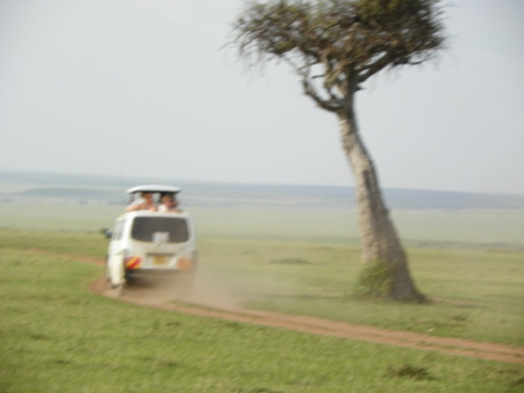
Safari is a very sought after tourist activity in Kenya. It takes place in a protected game reserve called Masai Mara. There are several ways to experience the game in Kenya but the most popular way is through a game drive. On a game drive a traveler wakes up in the early dawn, with their camera and water in tow, they board an open-top van and head out through the Savannah. In the early hours of the morning they can see hot air balloons with other tourists aboard them. As the van traverses through the many villages of the Maasai the scent of the morning kitchens prevails while they watch the herders in their red shuka herding their sacred cattle. As the caravan approaches a small, milky river the smell of the hippopotamus prevails. Then their distinctive snorting and blowing noises take over the smell and the larger than life animal emerges from the water. While looking atop the trees for leopards, one can see the vibrant colored birds partaking in their morning bath. As the van heads away from the river a young zebra can be spotted taking her mother’s milk. Off in the horizon a giraffe can be seen grazing from the acacia tree tops. The tall, graceful giraffe cocks his head and acknowledges the tourists as he returns to his breakfast. As the sun begins to beat down on the van the tourists return to their camp for lunch and a light nap.
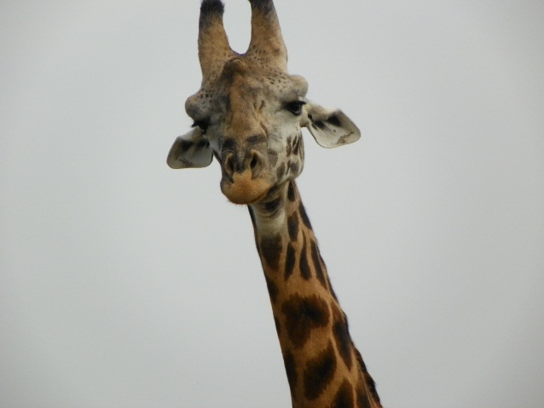
In the evening the jackals can be seen chasing their meal and the lions are resting by their daily catch and simultaneously guarding it from the invasion of the eagerly awaiting vultures. On the horizon, as the sun sets, the travelers can see the many ostriches wandering to their resting spot. In the distance the water buffalo, zebras, giraffes, and gazelles are migrating to safe ground together as if they were loading Noah’s Ark. The animals of the savannah live in harmony. They migrate in harmony and they communicate to protect one another from predators. In the savannah you can see Darwinism at its best for, the predators only prey on the weak and ill. The wildebeests that could not make the migration are removed from the gene pool when the rest of the herd returns. “Peace” and “living in harmony” is best demonstrated in the savanna. The simple observation of this “One World” should be applied to human kind. The peace and application of Darwinism would bring any human to shame. It makes a traveler re-evaluate the very principles that they live by. The most common response I heard during Safari was “Wow, look at them all living together!”
I believe that as humans looking for the meaning of life, we should study the “Circle of Life” in the Savannah of Kenya. We will see that by solely taking care of our own needs a competing tribesman or colleague would not affect our lives. In fact, their strengths would probably be our weaknesses and the simple application of their strengths may be the very thing that draws our attention to new ideas or dangers. Therefore, we as humans should learn from the animals and embrace the diversity they so easily accept.

Conclusion
Kenya is a very special place. It is raw and real. It is a microcosm of what history has forgotten to tell us. It is the true meaning of what it is to be human. Kenya has sustained humanity through the years. Kenya possesses an innocence that the rest of the world can only dream of. The very heart of Kenya is agriculture. The Kenyans identify with hunger and malnutrition. They understand that their nourishment does not just magically appear on grocers’ shelves. Kenyans enjoy the smell of burning wood for they know that that smell indicates food. It indicates warmth and above all it indicates life. Kenya is rich in history and the majority of Kenyans are proud of that history. They embrace diversity to the best of their abilities. They care for the ill and embrace the orphans. They give and expect nothing in return. They are survivors and above all they are real.
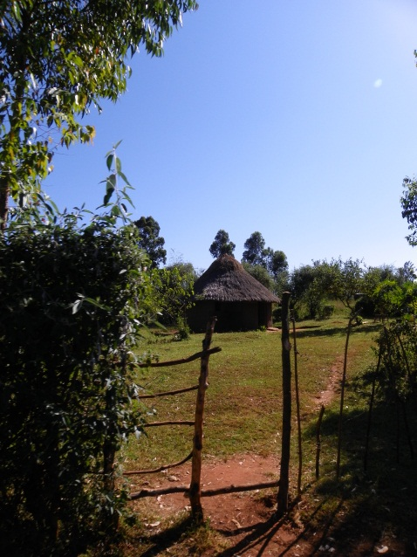
By removing any and all preconceived notions while traveling in Kenya, I was humbled and re – energized. The simple way that life is expressed throughout Kenya easily demonstrates the importance of living life to the fullest. The children want for little and the adults provide for their every basic need. The beauty of this way of life is that it defines what is important in life by simply surviving. Observing this simplicity that is accompanied by joy, smiles, and laughter, proves that the real importance in this world is simply to enjoy and always remember…
Hakuna Matata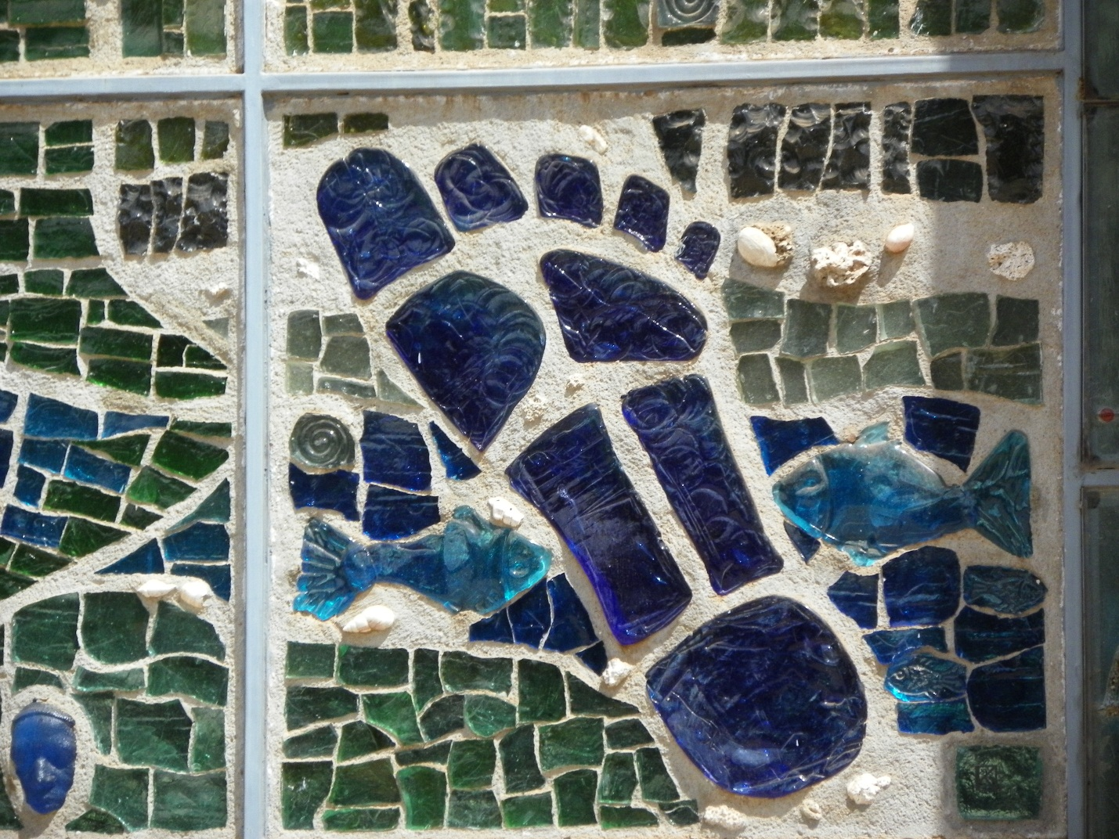

Works Cited
Barsby, J. (2007) Kenya Customs & Culture. Great Britain: Kuperard
Ghose, A.,& Awasthi, A. (Eds.). (2009).Kenya eyewitness travel. Great Britain: Dorling Kindersley Ltd.
Odhiambo, J. (2011 January 28). [Personal interview].

